
victorpumps.com
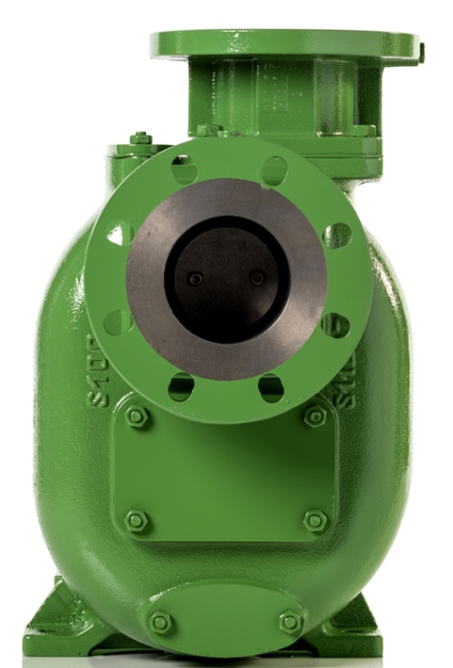
Self Priming Pumps

Recommended for corrosive and/or abrasive & viscous liquids, compatible with cast iron, bronze, aluminum or stainless steel, which can contain air.
The pump can be located above, on side or under the liquid. Some pump sizes can self-prime up to the physical limit of 8 m.
Available with various drives such as single phase, three-phase, explosion-proof motors and gasoline or diesel engine.
Produced in different versions depending on the specific application. Also with ATEX Certificate. 

Advantages

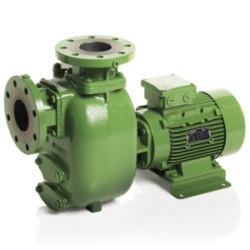
- Suction and discharge ports are available flanged or threaded (up to 4”). The threaded port have through-holes to take away faster the pipes.
- For easy installation, the DIN or ASA flanged ports have through-holes and ¼” threaded hole for Vacuum meter and manometer.
- Check valve: avoids backflow of liquid from the discharge side and reduces priming times. Available in NBR, Viton® (FKM), PTFE & EPDM.
- Maintenance-free ball bearings.
- Mechanical seal in Sic/Viton® (FKM) with stainless steel shaft sleeve and lubrication behind the seal to improve dry running capabilities.
- Heavy-duty open impeller and wear plate designed for abrasion and passage of solids. On request with cutting device for soft solids.

Stationary

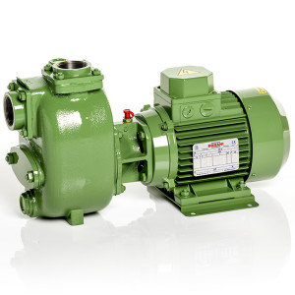
Close coupled pump
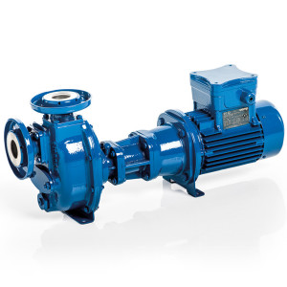
Bi-Block with flanged ports
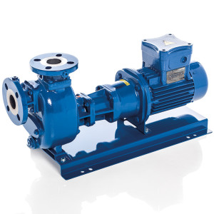
Bi-Block with flanged ports on base plate
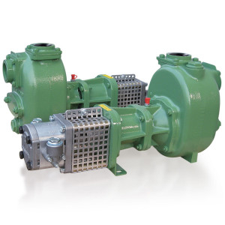
With hydraulic motor
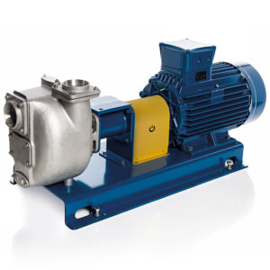
Classic, with elastic coupling, guard and B3 electric motor on base plate
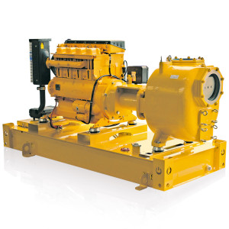
On tank frame

Mobile

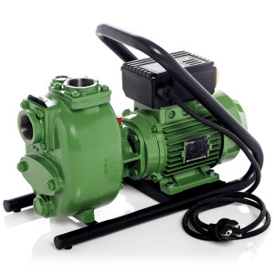
On carrying frame
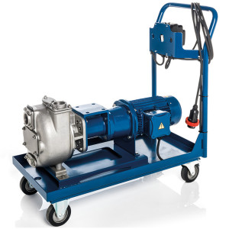
On trolley for flat ground
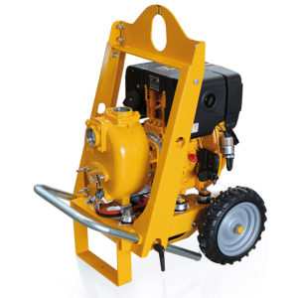
On trolley with 2 tractor profile wheels
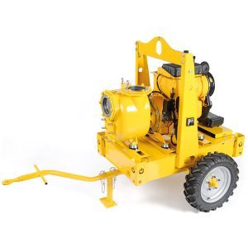
On trailer with tank
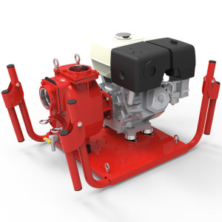
On carrying frame for the emergency
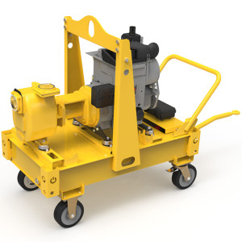
On trailer with tank & 4 wheels for flat ground

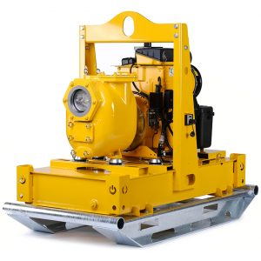
On skid

..\PV VENTS.pdf

